1. Missing Data Handling and Imputation Validation

Overview
Missing data refers to the absence of values for certain variables in a dataset. This is a common issue in real-world data and can significantly affect the accuracy and reliability of analysis if not properly handled. Therefore, it is essential to identify, quantify, and appropriately treat missing values before proceeding with further analysis.Missing data occurs when no value is stored for a variable in an observation. If not properly handled, it can introduce bias, reduce statistical power, and compromise the validity of conclusions.
In this study, missing data was systematically evaluated and handled using Multiple Imputation, specifically:
- Predictive Mean Matching (PMM) → preserves realistic values
- Random Forest (RF) → captures nonlinear relationships
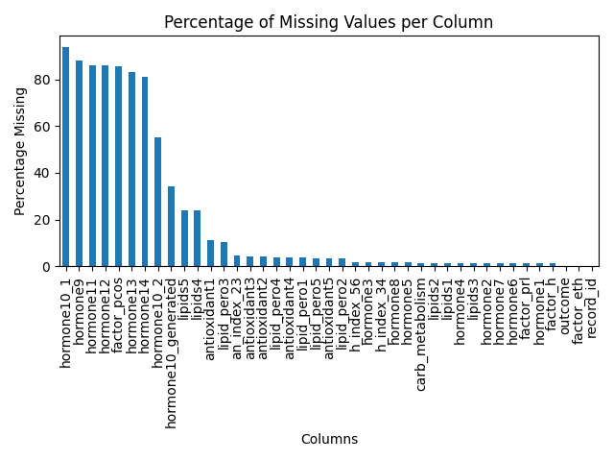
Figure 1: Percentage of Missing Values Across Variables
The above figure, illustrates the proportion of missing values across all variables in the datasets. The visualization reveals that while some variables contain minimal missing values, others exhibit moderate to high levels of missingness. Variables with less than 35% missing values were retained, as they still provide meaningful information for analysis. However, variables exceeding this threshold were removed to prevent distortion of results and ensure analytical reliability.
The uneven distribution of missing data suggests that the data is not uniformly missing across variables, which may indicate underlying patterns such as Missing at Random (MAR) or Missing Not at Random (MNAR). This reinforces the need for robust imputation techniques rather than simple deletion methods.

SECTION 2: IMPUTATION AND VALIDATION
After identifying missing values, multiple imputation techniques were applied to estimate and replace missing entries. This study employed methods such as Predictive Mean Matching and Random Forest imputation to preserve the statistical properties of the dataset. To evaluate the effectiveness of the imputation process, density plots were used to compare the distribution of original and imputed data.
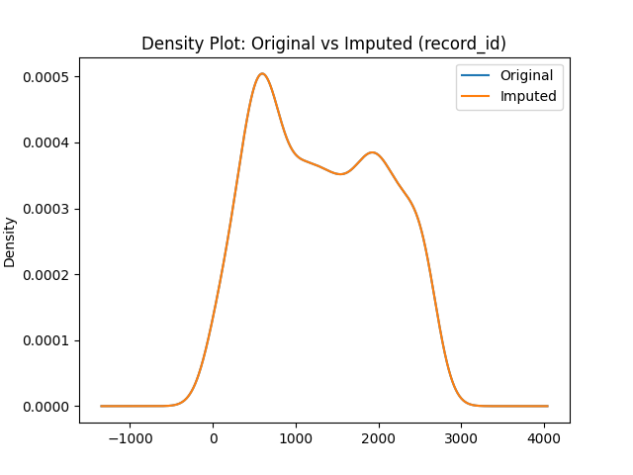
Figure 2: Distribution Comparison of Original and Imputed Data
Figure 2 compares the distribution of observed (original) data with the imputed dataset. The purpose of this comparison is to assess whether the imputation method has preserved the underlying structure of the data. A close alignment between the two curves indicates that the imputed values are realistic and do not introduce bias.
In this analysis, the imputed distribution closely follows the original distribution, suggesting that the imputation method successfully maintained key statistical properties such as central tendency and variability. This confirms that the dataset remains suitable for further statistical analysis and modeling.
Any significant deviation between the two curves would indicate distortion caused by imputation; however, such distortion is not observed here, demonstrating the robustness of the applied methods.

SECTION 3: OUTLIER DETECTION (BOXPLOT METHOD)
Outliers are extreme values that differ significantly from the majority of observations. Detecting outliers is essential because they can influence statistical results, distort model performance, and lead to misleading conclusions. In this study, boxplots based on the interquartile range (IQR) were used as an initial method for identifying outliers.
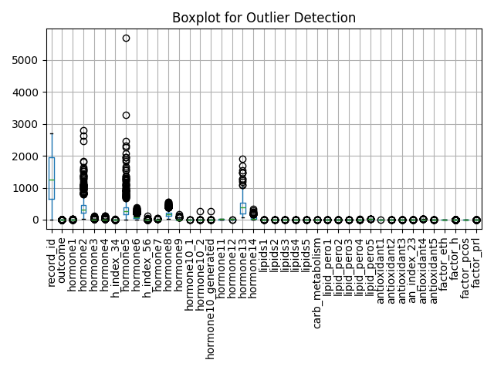
Fig 3: Boxplot for Detection of Outliers Across Variables
This presents boxplots for all numerical variables, highlighting the distribution and spread of the data. The box represents the interquartile range (IQR), which contains the middle 50% of observations, while the line inside the box indicates the median. Points located outside the whiskers represent potential outliers.
The visualization reveals the presence of multiple extreme values across several variables, indicating variability within the dataset. Some variables show wider boxes, suggesting higher dispersion, while others appear more concentrated. These findings confirm that the dataset contains both moderate and extreme outliers, necessitating further investigation using more advanced techniques.

SECTION 4: ADVANCED OUTLIER DETECTION (LOF METHOD)
While boxplots provide a useful visual method for detecting outliers, they are limited in identifying complex patterns in high-dimensional data. Therefore, the Local Outlier Factor (LOF) method was applied as an advanced technique to detect anomalies based on local data density.
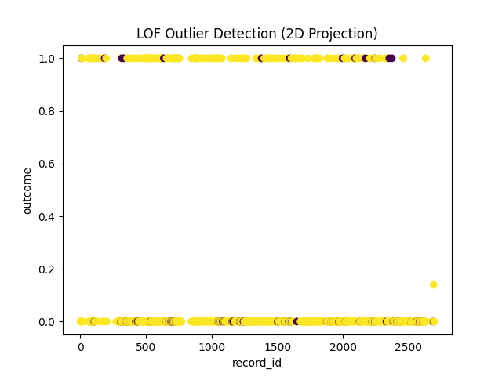
Fig 4: Outlier Detection Using Local Outlier Factor (LOF)
The above illustrates the results of the LOF algorithm, which classifies observations based on their local density relative to neighboring points. Observations that are significantly less dense than their surroundings are identified as outliers.
In this analysis, 76 observations were classified as outliers, while the majority were identified as normal data points. This indicates that a small but important portion of the dataset exhibits anomalous behavior.
Unlike traditional methods, LOF captures subtle deviations that may not be visible in boxplots, making it particularly effective for complex datasets. The presence of these outliers may reflect rare events, measurement inconsistencies, or genuine extreme cases. Therefore, careful consideration is required before deciding whether to remove or retain these observations.
Overall, the combined use of missing data analysis, imputation validation, and both classical and advanced outlier detection techniques provides a comprehensive preprocessing framework. The results demonstrate that the dataset has been carefully cleaned and validated, ensuring that subsequent analyses are both reliable and accurate.

